EXPERIMENT-1 (question 1)
Name: Teja Hasini Reddy
Roll_no: 2520030048
Section: 8
Experiment No. 1 (question 1)
Title: Installation of Linux VM, GCC Configuration, Git Repository Setup, Shell Architecture Analysis, and Process Creation using fork(), exec(), and System Call Tracing.
Aim: To set up a Linux development environment (VM, GCC, Git, Makefile, Project Structure) and write a C program to demonstrate process abstraction, execution of the exec() family, parent-child relationships, process tree inspection, and system call tracing using strace.
Objective:
- To set up a functional Linux environment, build system (make), and revision control (git).
- To understand shell architecture and process abstraction in operating systems.
- To learn process creation using the fork() system call.
- To execute external binaries using the exec() family of system calls (execlp, execvp).
- To observe process relationships (parent-child, process trees using pstree/ps).
- To trace and analyze system calls made by a process using tools like strace.

- Theory:

- Linux Development Environment & Shell Architecture:

- GCC & Makefile: GCC (GNU Compiler Collection) compiles C programs into executable binaries. A Makefile automates the compilation process using rules and target dependencies.
- Git: A distributed version control system used to track changes in code files and manage project structure.
- Shell Architecture: The Linux shell acts as a command-line interface (CLI) that reads user input, parses commands, creates child processes using fork(), replaces process images using exec(), and waits for completion using wait().
- Process Abstraction & Management System Calls:
1. fork():
- Creates a new child process.
- The child process is an exact copy of the parent.
- Returns:
  - 0 to the child process.
  - Child PID to the parent process.
  - -1 if creation fails.
2. exec():
The exec() family replaces the current process image with a new program.
Common functions are:
- execl()
- execv()
- execlp()
- execvp()
In this experiment, the child process executes the user-entered Linux command.
3. wait():
The parent process waits until the child process finishes execution.
This prevents zombie processes.
Algorithm:
- Start the program.
- Accept a Linux command from the user.
- Create a child process using fork().
- If child process:
  - Execute the command using execlp() or execvp().
- If parent process:
  - Wait for the child process using wait().
- Display Parent PID and Child PID.
- Stop.
System Calls Used:
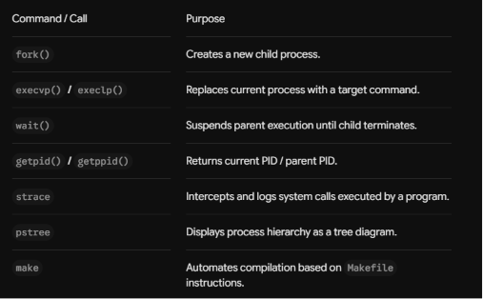
Sample Output:
Passing Students: {'Alice': 85, 'Charlie': 92, 'Evan': 78}
Average Score: 85.00
- Algorithm:
- Initialize project directory structure and initialize a Git repository using git init.
- Create a Makefile to compile source code with gcc.
- Read the user input (command name).
- Call fork() to spawn a child process.
- Child Process (PID == 0):
- Display child PID and parent PID.
- Execute command using execlp() / execvp().
- Parent Process (PID > 0):
- Display parent PID and created child PID.
- Call wait(NULL) to block until the child finishes.
- Run the executable with strace to observe low-level system call sequences (clone/fork, execve, wait4).

Result:
The program was successfully executed. The Linux command entered by the user was executed through a child process. The parent process waited for the child process to complete execution, and the Process IDs of both parent and child were displayed successfully.

Code:
#include <stdio.h>
#include <unistd.h>
#include <sys/types.h>
#include <sys/wait.h>

int main() {
pid_t pid;

printf("Parent process started (PID: %d)\n", getpid());

pid = fork(); // create child process

if (pid < 0) {
perror("Fork failed");
return 1;
}
else if (pid == 0) {
// Child process
printf("Child process (PID: %d, Parent PID: %d)\n", getpid(), getppid());

// Replace child with "ls" program using exec
execlp("ls", "ls", "-l", NULL);

// If exec fails
perror("Exec failed");
}
else {
// Parent process waits for child
wait(NULL);
printf("Parent process (PID: %d) finished waiting for child.\n", getpid());
}

return 0;
}
OUPUT:
